COURSE: OPERATING SYSTEM
PROJECT REPORT

OBJECTIVE
The primary objective of this project is the successful installation, configuration, and integration of essential network services within a virtualized environment. This includes setting up communication between two Virtual Machines (VMs) and configuring various servers such as Web, FTP, DNS, DHCP, and Proxy.

Phase 1: Virtual Environment and Connectivity
In Phase 1, the foundational network infrastructure was established:
- Virtualization Setup: Two Virtual Machines were created using a Hypervisor (VirtualBox/VMware).
- Operating System: Ubuntu OS was installed on both machines, designated as Ubuntu 1 (Server) and Ubuntu 2 (Client).
- Network Configuration: Internal networking was configured to allow communication between both operating systems.
- Verification: Connectivity was verified using the ICMP protocol (ping command).

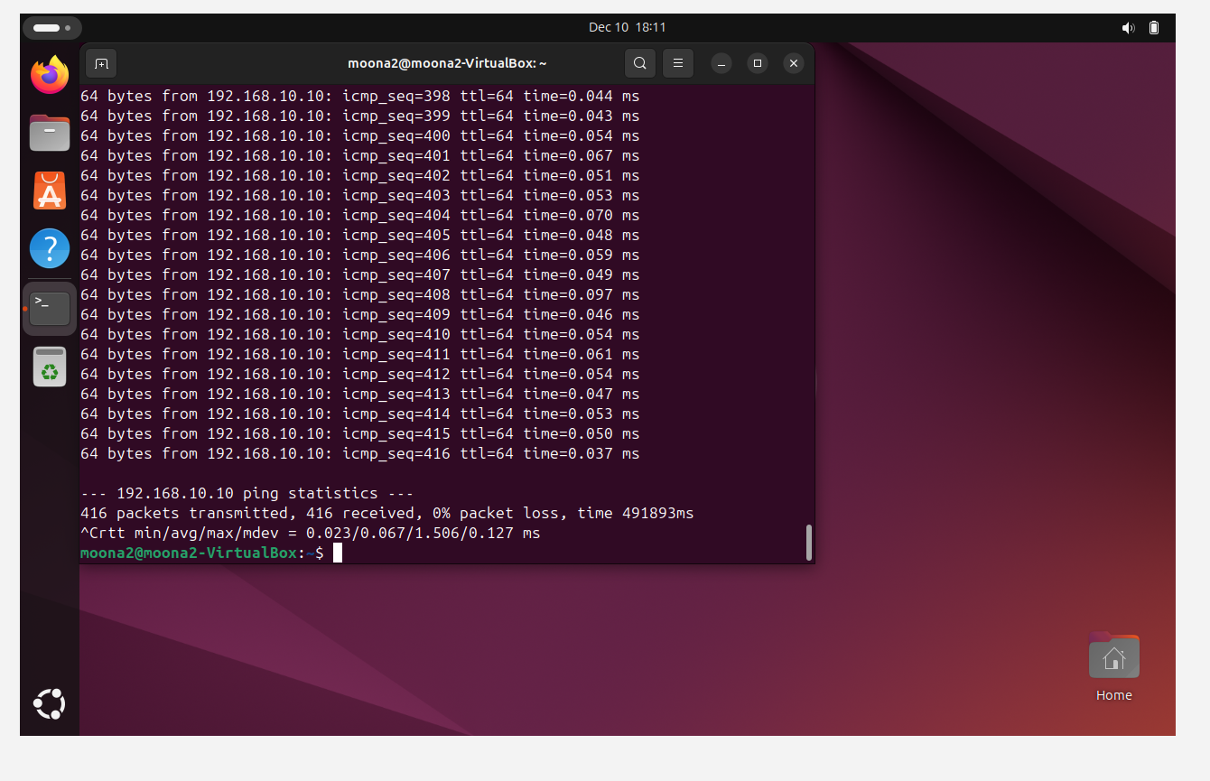

Phase 2: Server Setup and Configuration

DNS and DHCP Configuration
- DNS: The domain name moona.local was mapped to the static IP address 192.168.10.10.
- DHCP: A dynamic IP range was defined from 192.168.10.50 to 192.168.10.100 to automate client IP assignment.
- Status: The dnsmasq service was confirmed to be in an "active (running)" state.

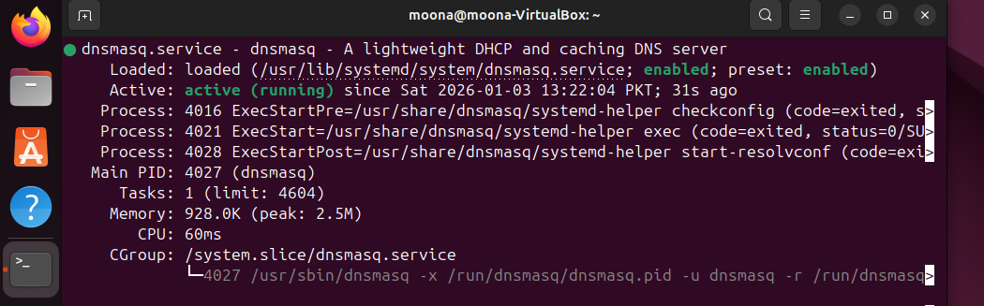

Web Server
• Task: The Apache2 web server was installed and configured to host web content.
• Verification: Accessibility was confirmed by loading the server's default page from the client browser via the local domain.

Proxy Server
• Task: The Squid proxy server was deployed to manage and filter network requests.
• Configuration: The service was configured to listen on the standard port 3128

FTP Server
• Task: The vsftpd service was installed to facilitate File Transfer Protocol (FTP) capabilities.
• Verification: Service initialization was confirmed through the system control manager.

Integration and Final Testing
To ensure all services were integrated correctly, a final end-to-end test was performed from the Client machine:
- Hostname Resolution: The /etc/hosts file on the client was updated to ensure reliable resolution of moona.local.
- Service Accessibility: Testing confirmed that the client could ping the server by name and access the hosted web services through a browser.
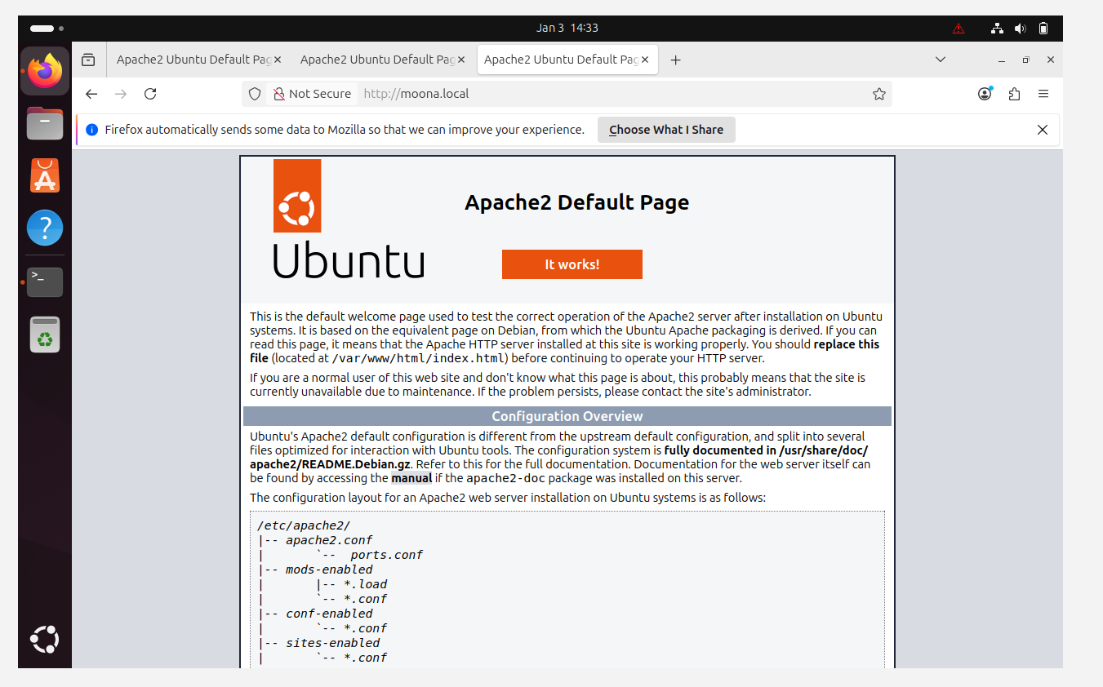

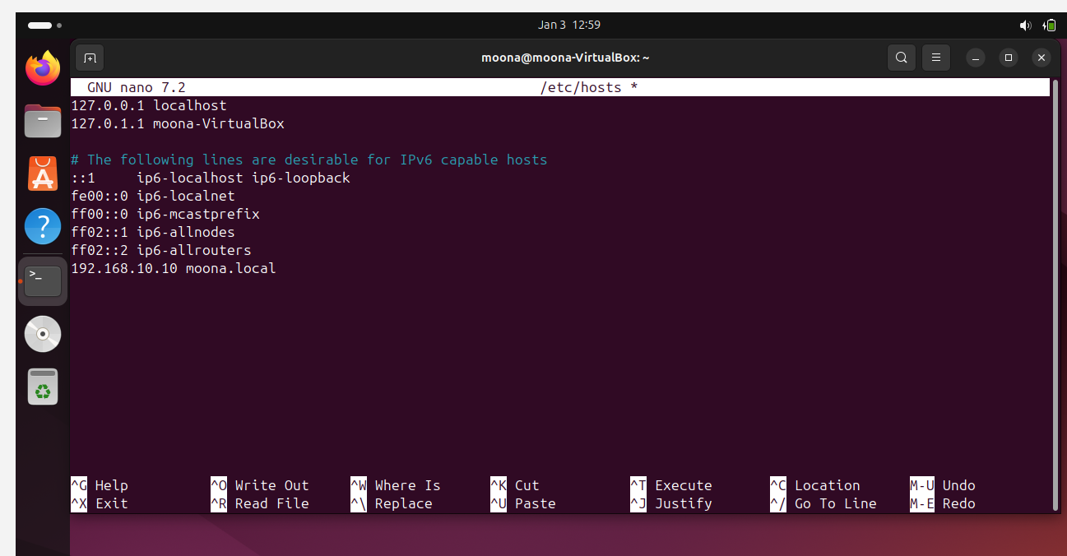

Conclusion
All requirements for Phase 1 and Phase 2 have been successfully completed. The project demonstrates a fully functional local network with integrated DNS, DHCP, Web, FTP, and Proxy services.

